Assembly-Based Shotgun Metagenomics Workflow
FASTQ → Contigs → MAGs → AMR / Virulence / MGE
Practical command-line guide based on the workflow developed in this project

1. Purpose and workflow position
This document describes the assembly-based branch for the previously analyzed sample SRR33005305. Kraken2/Bracken, MetaPhlAn and HUMAnN are read-based analyses and do not require assembly first. Assembly adds a genome-resolved layer: contigs → binning → MAGs → MAG annotation → AMR/virulence/MGE.
Clean paired FASTQ
↓
MEGAHIT assembly
↓
Contigs
↓
Read mapping → contig coverage
↓
Binning (MetaBAT2)
↓
Candidate MAGs
↓
Quality assessment
↓
MAG taxonomy + functional annotation
↓
AMR + virulence + MGE/plasmid analysis

2. Project-specific input
Item | Value
Sample | SRR33005305
R1 | 01_raw_data/SRR33005305_1.fastq.gz
R2 | 01_raw_data/SRR33005305_2.fastq.gz
Previously used HUMAnN input | 01_raw_data/humann_input/SRR33005305_combined.fastq.gz
Existing read-based analyses | Kraken2/Bracken, MetaPhlAn, HUMAnN 3.9
For assembly, use the paired R1/R2 files separately. The previously created combined FASTQ was suitable for the single-input tools used in the project, but should not be assumed to preserve paired-end structure for tools requiring -1/-2 inputs.
Summary Figures
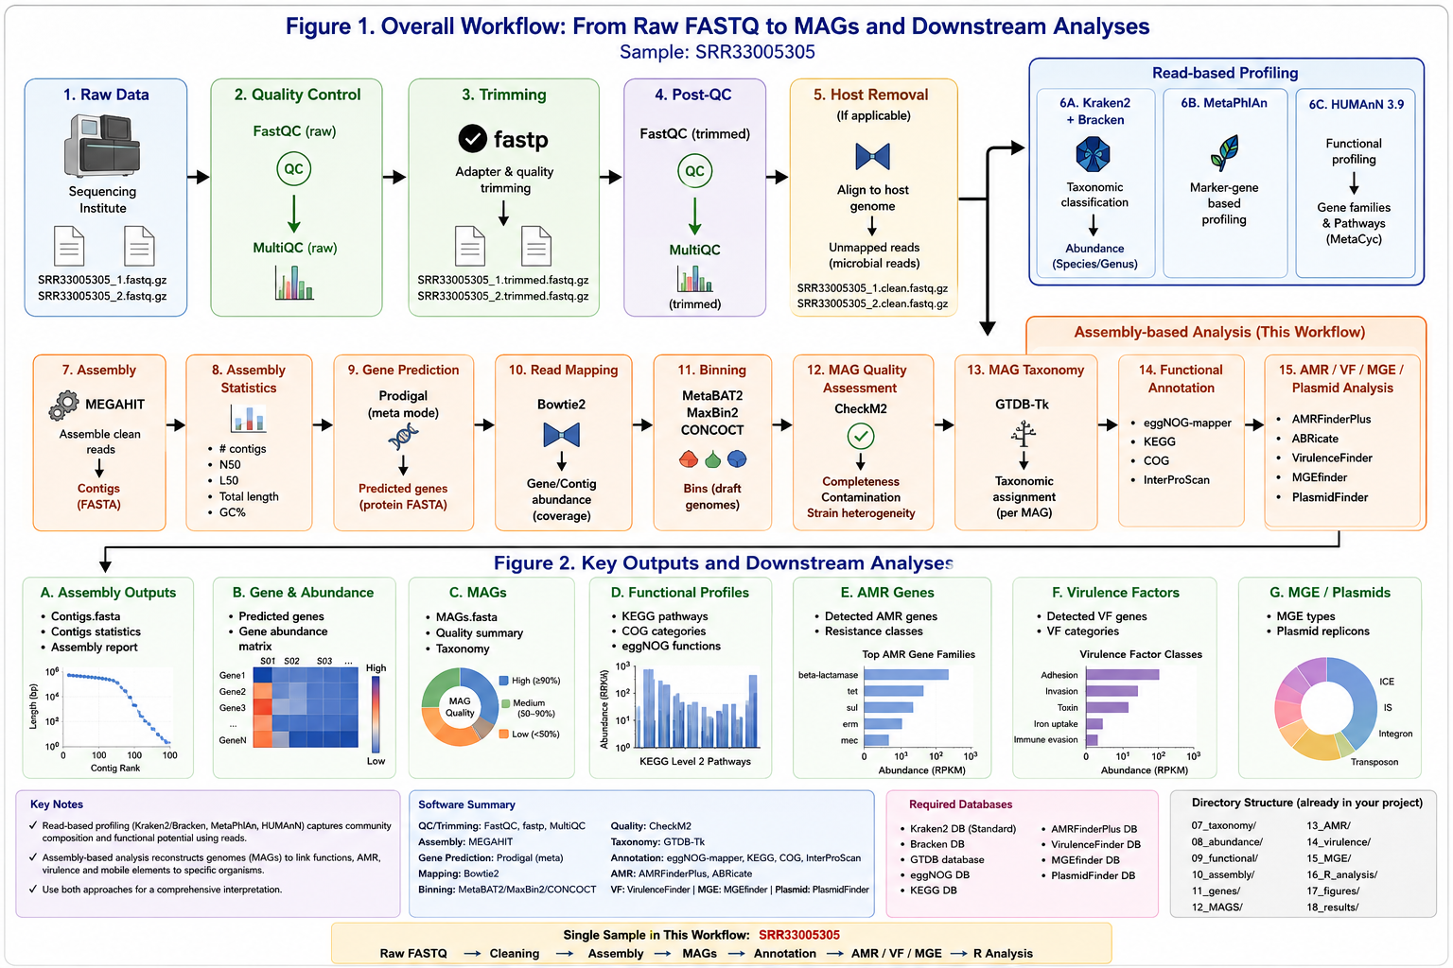
Figure 1–2. Visual summary of the SRR33005305 metagenomics workflow, showing the relationship between read-based profiling and the assembly/MAG-based branch.

3. Create directories
mkdir -p 10_assembly 11_genes 12_mapping 13_binning 14_MAG_quality \
15_MAG_annotation 16_AMR 17_virulence 18_MGE 19_MAG_summary

4. Check the paired reads
ls -lh 01_raw_data/SRR33005305_1.fastq.gz \
01_raw_data/SRR33005305_2.fastq.gz
zcat 01_raw_data/SRR33005305_1.fastq.gz | head -4
zcat 01_raw_data/SRR33005305_2.fastq.gz | head -4

5. Assembly with MEGAHIT
MEGAHIT reconstructs longer contigs from overlapping reads. These contigs are not yet individual genomes.
megahit \
-1 01_raw_data/SRR33005305_1.fastq.gz \
-2 01_raw_data/SRR33005305_2.fastq.gz \
-o 10_assembly/SRR33005305_megahit \
-t 20 \
--min-contig-len 500
Main output: 10_assembly/SRR33005305_megahit/final.contigs.fa

6. Assembly quality with QUAST
quast.py \
10_assembly/SRR33005305_megahit/final.contigs.fa \
-o 10_assembly/SRR33005305_quast
Sample | Raw reads | Contigs ≥500 bp | Total assembly (bp) | N50 (bp) | Largest contig (bp) | GC (%)
SRR33005305 | actual | actual | actual | actual | actual | actual

7. Gene prediction with Prodigal
prodigal \
-i 10_assembly/SRR33005305_megahit/final.contigs.fa \
-o 11_genes/SRR33005305_genes.gff \
-a 11_genes/SRR33005305_proteins.faa \
-d 11_genes/SRR33005305_genes.fna \
-p meta
The predicted genes/proteins become inputs for functional and gene-centric analyses.

8. Map reads back to contigs
Coverage is useful for assessing how strongly each contig is supported and for downstream binning/abundance analysis.
bowtie2-build \
10_assembly/SRR33005305_megahit/final.contigs.fa \
12_mapping/SRR33005305_contigs
bowtie2 \
-x 12_mapping/SRR33005305_contigs \
-1 01_raw_data/SRR33005305_1.fastq.gz \
-2 01_raw_data/SRR33005305_2.fastq.gz \
-p 20 \
| samtools view -bS - \
| samtools sort -o 12_mapping/SRR33005305_contigs.sorted.bam
samtools index 12_mapping/SRR33005305_contigs.sorted.bam

9. Generate coverage/depth for binning
jgi_summarize_bam_contig_depths \
--outputDepth 13_binning/SRR33005305_depth.txt \
12_mapping/SRR33005305_contigs.sorted.bam

10. Bin contigs into candidate MAGs with MetaBAT2
metabat2 \
-i 10_assembly/SRR33005305_megahit/final.contigs.fa \
-a 13_binning/SRR33005305_depth.txt \
-o 13_binning/SRR33005305_bin \
-m 1500 \
-t 20
Expected outputs include bins such as SRR33005305_bin.1.fa, SRR33005305_bin.2.fa, etc. These are candidate bins; they become useful MAGs only after quality assessment.

11. Assess MAG quality
Use CheckM or CheckM2 to estimate completeness and contamination. Retain bins according to the quality criteria you define before downstream biological interpretation.
# Example CheckM workflow
checkm lineage_wf \
-t 20 -x fa \
13_binning/ \
14_MAG_quality/checkm_out
checkm qa \
14_MAG_quality/checkm_out/lineage.ms \
14_MAG_quality/checkm_out \
-o 2 \
-f 14_MAG_quality/SRR33005305_MAG_quality.tsv
MAG | Completeness (%) | Contamination (%) | Genome size | Decision
MAG_001 | actual | actual | actual | retain/filter
MAG_002 | actual | actual | actual | retain/filter

12. Assign MAG taxonomy with GTDB-Tk
gtdbtk classify_wf \
--genome_dir 13_binning/ \
--out_dir 15_MAG_annotation/gtdbtk \
--cpus 20 \
--extension fa
Taxonomy may be resolved from domain through genus/species depending on the MAG and the GTDB database release.

13. Functional annotation of MAGs
Use a genome annotation tool such as Prokka, Bakta, DRAM or eggNOG-mapper. The exact command should match the tool/database version installed in your environment.
# Example for MAG_001
prokka \
--outdir 15_MAG_annotation/MAG_001 \
--prefix MAG_001 \
--cpus 20 \
13_binning/SRR33005305_bin.1.fa

14. AMR analysis
For your project, an assembly/MAG-based AMR screen can use ABRicate against ResFinder, as in the WGS workflow you previously developed.
abricate --db resfinder \
15_MAG_annotation/MAG_001/MAG_001.fna \
> 16_AMR/MAG_001_ResFinder.tsv
# Repeat for each retained MAG.
Record gene name, resistance class, identity and coverage. If you want to establish which reconstructed genome carries an AMR gene, MAG-level results are especially useful.

15. Virulence-factor analysis
abricate --db vfdb \
15_MAG_annotation/MAG_001/MAG_001.fna \
> 17_virulence/MAG_001_VFDB.tsv
For finer control, BLAST against VFDB can be used with explicitly defined identity/coverage thresholds and subsequent curation.

16. Mobile genetic elements (MGE)
Analyze retained MAGs/contigs with tools suited to the element of interest: insertion sequences, integrons, plasmids and other MGEs.
# Example: IntegronFinder
integron_finder \
--local-max \
--outdir 18_MGE/MAG_001 \
15_MAG_annotation/MAG_001/MAG_001.fna
# Example: MOB-suite plasmid reconstruction
mob_recon \
--infile 15_MAG_annotation/MAG_001/MAG_001.fna \
--outdir 18_MGE/MAG_001_mob

17. Example integrated MAG result
MAG | Taxonomy | Completeness | Contamination | AMR | VF | MGE | Status
MAG_001 | Bacteroides sp. | 96.2 | 2.1 | tetQ; ... | ... | IS/integron/... | retain
MAG_002 | Escherichia sp. | 93.7 | 1.8 | bla... | ... | plasmid/... | retain
MAG_003 | Enterococcus sp. | 89.4 | 3.2 | ermB; ... | ... | IS/... | retain

18. Tables for R analysis
- Assembly statistics: sample, contig count, total assembly length, N50, largest contig, GC.
- MAG quality: MAG ID, completeness, contamination, genome size, N50.
- MAG taxonomy: MAG ID plus GTDB-Tk taxonomy.
- Functional annotation/abundance: gene or MAG ID plus KEGG/COG/eggNOG annotations and abundance.
- AMR table/matrix: AMR gene × MAG/sample, identity, coverage and abundance where available.
- Virulence table/matrix: VF gene × MAG/sample, identity, coverage and abundance where available.
- MGE table: element, MAG/contig, element type and supporting evidence.

19. Relation to your completed read-based analysis
Component | Input | Main result
Kraken2/Bracken | Clean reads | Read-based taxonomy
MetaPhlAn | Clean reads | Marker-based taxonomy
HUMAnN 3.9 | Clean reads | Gene families + pathways
MEGAHIT | Paired clean reads | Contigs
MetaBAT2 | Contigs + coverage | Candidate MAGs
GTDB-Tk | MAGs | MAG taxonomy
Functional annotation | MAGs | Genome-resolved functions
AMR/VF/MGE | Contigs/MAGs | Genome/contig-associated AMR, virulence and mobile elements

20. Reproducibility checklist
- Record whether reads are raw, trimmed and host-depleted.
- Record assembler/version/parameters and minimum contig length.
- Record gene predictor/version.
- Record mapper/version and reference assembly.
- Record binning tool/version and parameters.
- Record CheckM/CheckM2 and database version.
- Record GTDB-Tk and GTDB database release.
- Record annotation and AMR/VF/MGE database versions.
- Keep raw TSV outputs before filtering.
- Define identity/coverage thresholds before interpretation.

21. Final workflow summary
CLEAN PAIRED FASTQ
↓
QC / trimming / host removal
↓
├── Kraken2 → Bracken → taxonomy
├── MetaPhlAn → taxonomy
├── HUMAnN → gene families/pathways
└── MEGAHIT → contigs
↓
read mapping
↓
binning
↓
MAGs
↓
quality assessment
↓
MAG taxonomy
↓
functional annotation
↓
AMR + virulence + MGE/plasmid
↓
integrated R analysis
Important: Commands are a project-specific template for SRR33005305. They should be executed only after confirming that the corresponding software, database and version are installed. CheckM/CheckM2, GTDB-Tk and MGE tools have release-specific options; keep the exact versions and database releases in your final methods record.

